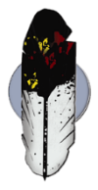
The Federal Emergency Management Agency (FEMA)
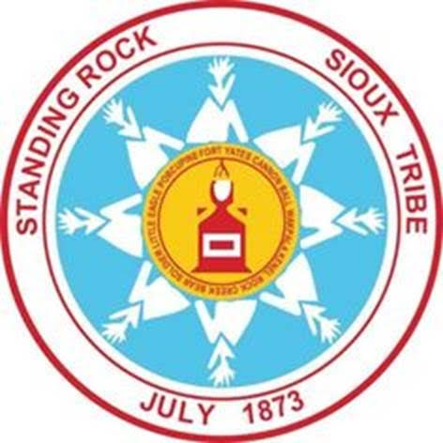
Emergency Management Institute (EMI)
and the

Standing Rock Sioux Tribe
invite you to attend the
EMI Tribal Train the Trainer (L8585)
July 8 -12, 2024 from 8:00 am - 5:00 pm
At the Prairie Knights Casino, 7932 Highway 24, Fort Yates, ND 58538

Course Purpose: To train Tribal members and Tribal personnel to deliver the FEMA Tribal curriculum to your own Tribal members in your own Tribal communities.

This 5-day course provides an in-depth and comprehensive training in instructional methods and delivery techniques in three of the Tribal courses of the FEMA Tribal curriculum

Intended Audience: Tribal emergency managers/emergency response personnel, Tribal government department heads and employees and Tribal leaders – all those who seek to support and engage in the successful preparation, response, and recovery from incidents and disasters while creating resilience and maintaining sovereignty for your people.

The training and materials are free.
Travel expenses are the responsibility of the student’s organization.
Lunch is being sponsored by the Standing Rock Sioux Tribe.

To sign up please contact
Harold Tiger at (605) 218-1170 or at Harold.tiger@standingrock.org

For Online Registration: DHS-FEMA General Admissions Application, To Register
- Please obtain a Student Identification Number: https://cdp.dhs.gov/femasid
- Please apply online: National Emergency Training Center Online Admissions Application (fema.gov)
Course number is L8585 Start Date: July 8, 2024.
- In-person registration will also be available day of class – if registering at class, please bring your SID number (may contact POC for assistance with obtaining a SID number)

HOTEL INFORMATION
Prairie Nights Casino Resort, 7932 Highway 24, Fort Yates, ND 58538

AIRPORT INFORMATION
Bismarck Municipal Airport (BIS), approximately 1.5 hours from Prairie Knights venue

