ICS-300 – Intermediate ICS for Expanding Incidents

Instructor Guide
October 2013

This page intentionally left blank.
Purpose |  | This course provides training on and resources for personnel who require advanced application of the Incident Command System (ICS).
 | Who Should Attend | The target audience for this course is individuals who may assume a supervisory role in expanding incidents. Note: During an expanding incident, some or all of the Command and General Staff positions may be activated, as well as Division/Group Supervisor and/or Unit Leader level positions. These incidents may extend into multiple operational periods.  This course expands upon information covered in the ICS-100 and ICS-200 courses. These earlier courses are prerequisites for ICS-300.
 | ICS Instructor Guidelines | The National Integration Center (NIC) is responsible for “facilitating the development of national guidelines for incident management training and exercises at all jurisdictional levels, while individual agencies and organizations are responsible for establishing and certifying instructors.” The NIC provides guidelines for ICS instructors.  While individual agencies and organizations are responsible for establishing and certifying instructors, the NIC urges those agencies and organizations to follow these guidelines.  The NIC recommends the following ICS general instructor guidelines:  Instructor Levels  - Lead instructors must be capable of last-minute substitution for unit instructors.  - Unit instructors must be experienced in the lesson content they are presenting.  - Adjunct instructors may provide limited instruction in specialized knowledge and skills at the discretion of the lead instructor. They must be experienced, proficient, and knowledgeable of current issues in their field of expertise.
 | ICS Instructor Qualifications  (Continued) | Adult Education recommendations for ICS-300 and ICS-400 Lead and Unit Instructors  Instructors should complete formal instructor training such as college courses, the National Wildfire Coordinating Group (NWCG)’s Facilitative Instructor M-410 course, the Emergency Management Institute (EMI)’s Master Trainer Program, the National Fire Academy (NFA)’s Instructional Methodology class, or the Office of Grants & Training’s (formerly known as Domestic Preparedness) Instructor Training Certification Course, or equivalent.  - At least two instructors are recommended to conduct ICS-300 classes;  - Lead instructor should have successfully completed ICS-400;  - Unit instructors should have successfully completed ICS-300;  - Lead instructor should have served as served as Incident Commander or in a Command Staff or General Staff position in an incident that went beyond one operational period or required a written Incident Action Plan (IAP); and  - Unit instructors should have served as served as Incident Commander or in a Command Staff or General Staff position; or, have specialized knowledge and experience appropriate for the audience, such as public health or public works.
 | Course Objectives | The course objectives are as follows:  - Describe how the NIMS Command and Management component supports the management of expanding incidents.  - Describe the incident/event management process for supervisors and expanding incidents as prescribed by the Incident Command System (ICS).  - Implement the incident management process on a simulated expanding incident.  - Develop an Incident Action Plan for a simulated incident.
 | Training Content | The training is comprised of the following lessons:  - Unit 1: Course Overview  - Unit 2: ICS Fundamentals Review  - Unit 3: Unified Command  - Unit 4: Incident/Event Assessment and Agency Guidance in Establishing Incident Objectives  - Unit 5: Planning Process  - Unit 6: Incident Resource Management  - Unit 7: Demobilization, Transfer of Command, and Closeout  - Unit 8: Course Summary  The table on the next page presents the recommended training agenda.

ICS-300 – Intermediate ICS for Expanding Incidents
Sample Agenda

DAY 1

Morning Session

- Unit 1: Course Overview (1 hour)
- Unit 2: ICS Fundamentals Review (2 hours 30 minutes)

Afternoon Session

- Unit 3: Unified Command (2 hours 15 minutes)
- Unit 4: Incident/Event Assessment and Agency Guidance in Establishing Incident Objectives (2 hours 20 minutes)

DAY 2

Morning Session

- Unit 4: Incident/Event Assessment and Agency Guidance in Establishing Incident Objectives (continued)
- Unit 5: Planning Process (3 hours 45 minutes)

Afternoon Session
- Unit 5: Planning Process (continued)
- Unit 6: Incident Resource Management (3 hours)

DAY 3

Morning Session

- Unit 7: Demobilization, Transfer of Command, and Closeout (2 hours 10 minutes)
- Unit 8: Course Summary (1 hour)

Recommended course length is a minimum of 18 hours not including breaks.
ICS Training and NIMS | The National Incident Management System (NIMS) National Standard Curriculum: Training Development Guidance outlines the System's ICS concepts and principles, management characteristics, organizations and operations, organizational element titles, and recommendations for a model curriculum. It also provides an evaluation checklist for content that may be used to make sure that the training meets the "as taught by DHS" standard. The guidance document is available for download from the NIMS homepage at www.fema.gov/emergency/nims.  The model NIMS ICS curriculum organizes four levels of training: ICS-100, Introduction to ICS; ICS-200, Basic ICS; ICS-300, Intermediate ICS; and ICS-400, Advanced ICS. ICS training provided by EMI, NFA, NWCG, the U.S. Department of Agriculture (USDA), the Environmental Protection Agency (EPA), and the U.S. Coast Guard (USCG) follow this model.  According to the NIC, emergency management and response personnel already ICS trained do not need retraining if their previous training is consistent with the DHS standard. This would include ICS courses managed, administered, or delivered by EMI, NFA, NWCG, USDA, EPA, or USCG. Questions concerning NIMS and related training issues may be directed to: fema-nims@dhs.gov.

Course Logistics Overview
Course Materials |  | Listed below are the materials that you will need in order to conduct this course:  - Instructor Guide and Resource CD: Obtain one copy of the Instructor Guide and resource CD for each trainer.  - Student Manual: Secure one copy of the Student Manual for each person attending the session.  - Activity Materials: Some activities in this course are based on continuing scenarios, with each unit building on the work completed in prior units. Select one scenario to start at the beginning of the course and continue it through the end of the course. For the scenario you select you will need to make enough copies of the Student Handouts for each participant.  Scenario Options: Select one of the following:  - Emerald City Flood  - Crescent City HazMat Incident  - Pet Food Recall  - Avian Influenza  - Coqui Frogs  - Earthen Dam Failure  - Hospital  - School Fire  - Wildfire  - Winter Storm  - Basketball Game  - PowerPoint Files CD: The course visuals are stored on a CD. Transfer the course visuals from the CD to the hard drive of a computer. The visuals will operate more effectively if they are accessed from the computer’s hard drive instead of the CD. Complete the following steps for copying the folders and files from the CD:  - Insert the Visuals CD into your CD drive.  - Using Windows Explorer, access the list of folders and files on your CD drive.  - Highlight the folder on the CD titled “visuals.”  - With the visual folder highlighted, click on the Edit pull-down menu and then select Copy.  - Select a location on your computer’s hard drive. When you are in that drive (and folder), click on the Edit pull-down menu and then select Paste.  - All of the visuals should now be copied onto your hard drive.  - Test the visuals to make sure that everything transferred correctly.  - Course Evaluation Forms: Secure one copy of the course evaluation form for each person attending the training. Course evaluation forms are typically provided by the organization sponsoring the course.
Course Equipment |  | Make arrangements to have a computer with a PowerPoint slide projector. Be sure to try out the projector in advance of the training, in case you need help getting it to work properly. Make sure all equipment is functioning properly.  Test the PowerPoint projector and the lights. If you do not have equipment for projection, plan to refer participants to their Student Manuals. The visuals are reproduced in the Student Manual, but the training is more effective with the projection of the visuals. Arrange for technical assistance to be available during training in the event of equipment malfunction.
 | Copyright | This course makes no use of copyrighted/proprietary material.

Unit 1: Course Overview

This page intentionally left blank.

Course Objectives

At the end of this course, the participants should be able to:

- Describe how the NIMS Command and Management component supports the management of expanding incidents.
- Describe the incident/event management process for supervisors and expanding incidents as prescribed by the Incident Command System (ICS).
- Implement the incident management process on a simulated expanding incident.
- Develop an Incident Action Plan for a simulated incident.

Scope

- Instructor Introductions
- Unit Objectives
- Course Objectives
- Student Introductions and Expectations
- Instructor Expectations
- Course Structure
- Course Logistics
- Successful Course Completion
- Activity: Team Formation
- Summary

Methodology

The lead instructor will welcome participants to the class and introduce himself/herself. Using a visual, the instructor will review the unit and course objectives. Next, participants will introduce themselves and identify their expectations. Then the instructor will identify his/her expectations.

Following the introductions, the course structure, agenda, and logistics will be presented. The instructor will also explain the course completion requirements, including a course final exam.

An activity will be used to energize the group and to form participants into teams that will work together for the duration of the course. Team members will be given the opportunity to introduce themselves, choose a team leader, and decide how they will operate during the course.

The lead instructor will conclude the unit by asking participants if they can accomplish the unit objectives.

Materials

- PowerPoint visuals 1.1 – 1.11
- Instructor Guide
- PowerPoint slides and a computer display system
- Student Manual

Time Plan

A suggested time plan for this unit is shown below. More or less time may be required, based on the experience level of the group.

Topic | Time
Welcome and Instructor Introductions | 5 minutes
Unit and Course Objectives | 5 minutes
Student Introductions and Expectations  Instructor Expectations | 15 minutes
Course Structure  Course Logistics  Successful Course Completion | 10 minutes
Activity: Team Formation | 20 minutes
Summary | 5 minutes
Total Time | 1 hour

COURSE WELCOME

Visual 1.1

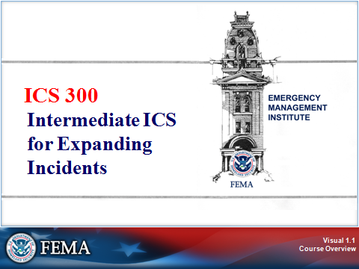

Instructor Notes: Present the following key points.

Welcome the participants to the ICS-300 course. Explain that this course focuses on ICS for supervisors in expanding incidents. Note that this course builds on the ICS-100 and ICS-200 courses.

Introduce yourself and provide information about your background and experience with the Incident Command System (ICS). Discuss your operational experience using ICS on multioperational-period incidents.

Ask other instructors to introduce themselves in the same way.

Unit objecives

Visual 1.2

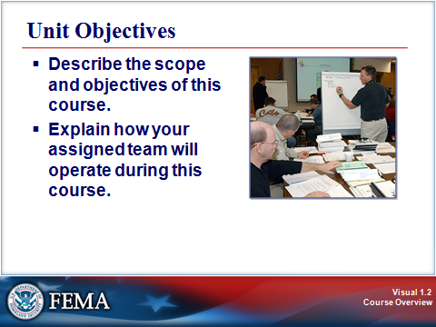

Instructor Notes: Present the following key points.

Review the unit objectives with the class. Tell the participants that by the end of this unit, they should be able to:

- Describe the scope and objectives of this course.
- Explain how their assigned team will operate during this course.

COURSE OBJECTIVES

Visual 1.3

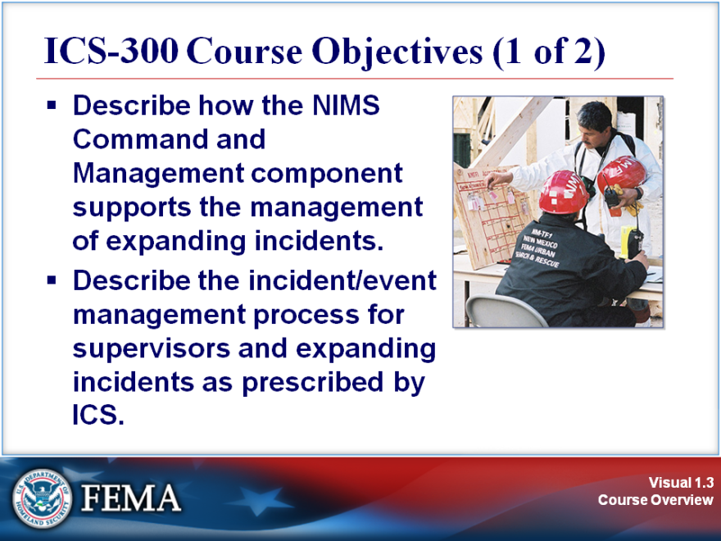

Instructor Notes: Present the following key points.

This course is designed to provide overall incident management skills rather than tactical expertise. Additional courses are available on developing and implementing incident tactics.

Tell the participants that by the end of this course, they should be able to:

- Describe how the NIMS Command and Management component supports the management of expanding incidents.
- Describe the incident/event management process for supervisors and expanding incidents as prescribed by ICS.
COURSE OBJECTIVES

Visual 1.4

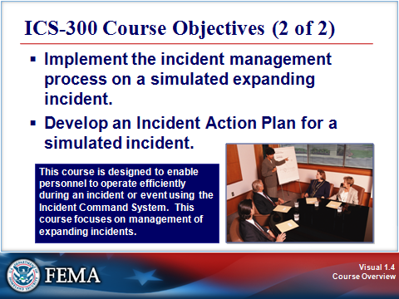

Instructor Notes: Present the following key points.

Continue reviewing the following course objectives with the class:

- Implement the incident management process on a simulated expanding incident.
- Develop an Incident Action Plan for a simulated incident.

Student Introductions and Expectations

Visual 1.5

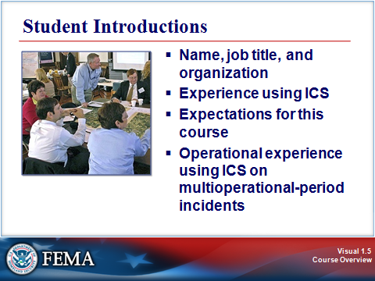

Instructor Notes: Present the following key points.

Complete the student introductions by asking the participants to present their:

- Name, job title, and organization.
- Experience using ICS.
- Expectations for this course.
- Operational experience using ICS on multioperational-period incidents.

Ask the participants to each mention one thing they hope to learn in this course.

If possible, summarize the expectations on chart paper.

Based on the expectations presented, clarify if there are any topic areas that are beyond the scope of this course.

Save the expectations list. During the course summary, you may want to use this list to see how well the course met the group’s expectations.

Instructor Expectations

Visual 1.6

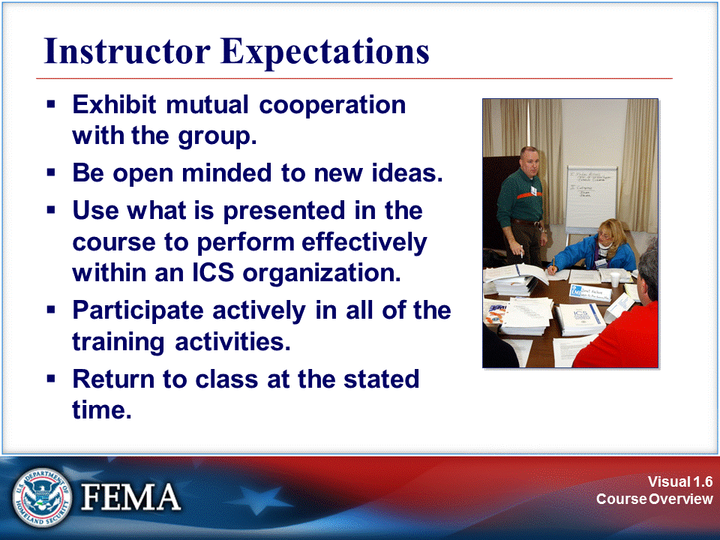

Instructor Notes: Present the following key points.

Briefly review the instructional team’s expectations. Note that instructors expect course participants will:

- Cooperate with the group.
- Be open minded to new ideas.
- Use what they learn in the course to perform effectively within an ICS organization.
- Participate actively in all of the training activities.
- Return to class at the stated time.

COURSE STRUCTURE

Visual 1.7

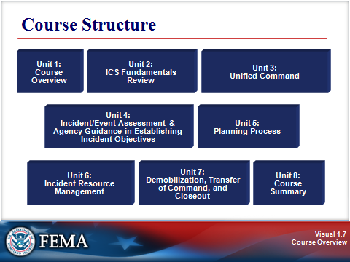

Instructor Notes: Present the following key points.

This course includes the following eight lessons:

- Unit 1: Course Overview (Current lesson)
- Unit 2: ICS Fundamentals Review
- Unit 3: Unified Command
- Unit 4: Incident/Event Assessment and Agency Guidance in Establishing Incident Objectives
- Unit 5: Planning Process
- Unit 6: Incident Resource Management
- Unit 7: Demobilization, Transfer of Command, and Closeout
- Unit 8: Course Summary

Review the Course Agenda with the participants.

COURSE LOGISTICS

Visual 1.8

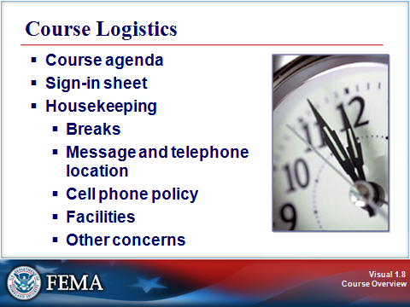

Instructor Notes: Present the following key points.

Review the following course logistics:

- Sign-in sheet

- Housekeeping issues:
- Breaks, including lunch breaks
- Message and telephone location
- Cell phone policy, including instructions on turning cell phones to “meeting” or “vibrate” during class times
- Facilities
- Other concerns

Successful Course Completion

Visual 1.9

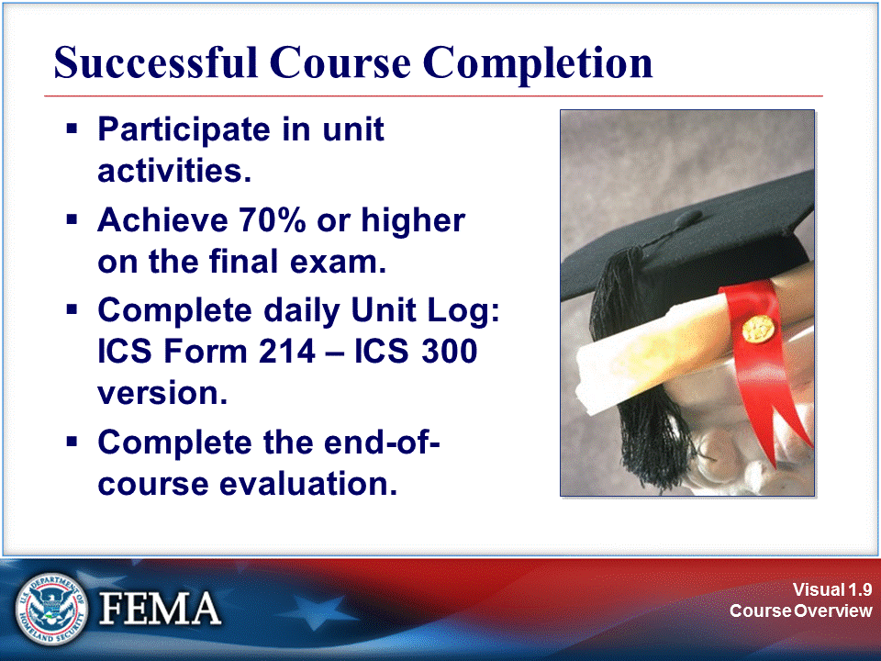

Instructor Notes: Present the following key points.

Successful course completion requires that participants:

- Participate in unit activities.
- Achieve 70% or higher on the final exam.
- Complete daily unit log: ICS Form 214 – ICS 300 version
- Complete the end-of-course evaluation.

Refer the participants to the ICS Form 214 – ICS 300 version that appears on the next page. Explain that this unit log has been adapted for use during this course. Tell the participants that they are required to complete this log by the end of each day of training. Give the participants time to review the log.

Ask the participants if they have any questions.

ACTIVITY LOG (ICS 214)

1. Incident Name: |  |  | 2. Operational Period: Date From: Date To:  Time From: Time To:
3. Name: |  | 4. ICS Position: |  |  | 5. Home Agency (and Unit):
6. Resources Assigned:
Name |  | ICS Position |  |  | Home Agency (and Unit)
7. Activity Log:
Date/Time | Notable Activities
8. Prepared by: Name: Position/Title: Signature:
ICS 214, Page 1 |  |  |  | Date/Time:

UNIT LOG ICS 214 – ICS 300 Course

Activity: Team Formation

Visual 1.10

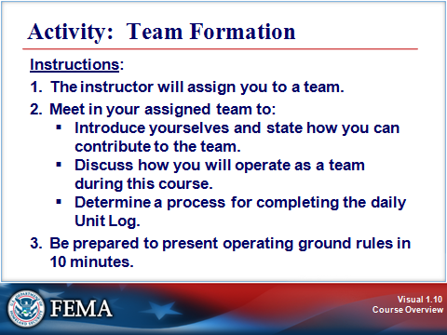

Instructor Notes: Present the following key points.

Purpose: The purpose of this activity is to assign participants to teams and to provide the opportunity for the team members to introduce themselves, decide how they will operate during activities throughout the course, and determine a process for completing the daily unit log.

Instructions: Show the visual and explain the instructions for this activity:

- The instructor will assign you to a team.

- Meet in your assigned team to:
- Introduce yourselves and state how you can contribute to the team (e.g., summarize team discussions on easel charts for presentation to the class, serve as a spokesperson for the team when needed, actively participate in team discussions).
- Discuss how you will operate as a team during activities and other assignments throughout this course.
- Determine a process for completing the daily unit log.

- Be prepared to present your operating ground rules in 10 minutes.

Debrief the activity by asking each team spokesperson to briefly present the operating ground rules that the team will use during activities and other assignments throughout this course, and to describe the process they’ll use for completing the daily unit log.

SUMMARY

Visual 1.11

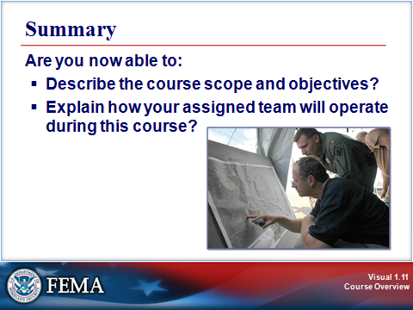

Instructor Notes: Present the following key points.

Show the visual and summarize this unit by asking the following questions:

Are you now able to:

- Describe the course scope and objectives?
- Explain how your assigned team will operate during this course?

Tell participants that the next unit is ICS Fundamentals Review, which will start after a break.

ICS-300 – Intermediate ICS for Expanding Incidents
Sample Agenda

DAY 1

Morning Session

- Unit 1: Course Overview (1 hour)
- Unit 2: ICS Fundamentals Review (2 hours 30 minutes)

Afternoon Session

- Unit 3: Unified Command (2 hours 15 minutes)
- Unit 4: Incident/Event Assessment and Agency Guidance in Establishing Incident Objectives (2 hours 20 minutes)

DAY 2

Morning Session

- Unit 4: Incident/Event Assessment and Agency Guidance in Establishing Incident Objectives (continued)
- Unit 5: Planning Process (3 hours 45 minutes)

Afternoon Session
- Unit 5: Planning Process (continued)
- Unit 6: Incident Resource Management (3 hours)

DAY 3

Morning Session

- Unit 7: Demobilization, Transfer of Command, and Closeout (2 hours 10 minutes)
- Unit 8: Course Summary (1 hour)

Accessible: Having the legally required features and/or qualities that ensure easy entrance, participation, and usability of places, programs, services, and activities by individuals with a wide variety of disabilities.
Acquisition Procedures: Used to obtain resources to support operational requirements.
Agency: A division of government with a specific function offering a particular kind of assistance. In the Incident Command System, agencies are defined either as jurisdictional (having statutory responsibility for incident management) or as assisting or cooperating (providing resources or other assistance). Governmental organizations are most often in charge of an incident, though in certain circumstances private sector organizations may be included. Additionally, nongovernmental organizations may be included to provide support.
Agency Administrator/Executive: The official responsible for administering policy for an agency or jurisdiction, having full authority for making decisions, and providing direction to the management organization for an incident.
Agency Dispatch: The agency or jurisdictional facility from which resources are sent to incidents.
Agency Representative: A person assigned by a primary, assisting, or cooperating Federal, State, tribal, or local government agency or private organization that has been delegated authority to make decisions affecting that agency's or organization's participation in incident management activities following appropriate consultation with the leadership of that agency.
All-Hazards: Describing an incident, natural or manmade, that warrants action to protect life, property, environment, public health or safety, and minimize disruptions of government, social, or economic activities.
Allocated Resources: Resources dispatched to an incident.
Area Command: An organization established to oversee the management of multiple incidents that are each being handled by a separate Incident Command System organization or to oversee the management of a very large or evolving incident that has multiple incident management teams engaged. An agency administrator/executive or other public official with jurisdictional responsibility for the incident usually makes the decision to establish an Area Command. An Area Command is activated only if necessary, depending on the complexity of the incident and incident management span-of-control considerations.
Assessment: The evaluation and interpretation of measurements and other information to provide a basis for decisionmaking.
Assigned Resources: Resources checked in and assigned work tasks on an incident.
Assignments: Tasks given to resources to perform within a given operational period that are based on operational objectives defined in the Incident Action Plan.
Assistant: Title for subordinates of principal Command Staff positions. The title indicates a level of technical capability, qualifications, and responsibility subordinate to the primary positions. Assistants may also be assigned to unit leaders.
Assisting Agency: An agency or organization providing personnel, services, or other resources to the agency with direct responsibility for incident management. See Supporting Agency.
Available Resources: Resources assigned to an incident, checked in, and available for a mission assignment, normally located in a Staging Area.
Badging: Based on credentialing and resource ordering, provides incident-specific credentials and can be used to limit access to various incident sites.
Base: The location at which primary Logistics functions for an incident are coordinated and administered. There is only one Base per incident. (Incident name or other designator will be added to the term Base.) The Incident Command Post may be co-located with the Base.
Branch: The organizational level having functional or geographical responsibility for major aspects of incident operations. A Branch is organizationally situated between the Section Chief and the Division or Group in the Operations Section, and between the Section and Units in the Logistics Section. Branches are identified by the use of Roman numerals or by functional area.
Cache: A predetermined complement of tools, equipment, and/or supplies stored in a designated location, available for incident use.
Camp: A geographical site within the general incident area (separate from the Incident Base) that is equipped and staffed to provide sleeping, food, water, and sanitary services to incident personnel.
Certifying Personnel: Process that entails authoritatively attesting that individuals meet professional standards for the training, experience, and performance required for key incident management functions.
Chain of Command: A series of command, control, executive, or management positions in hierarchical order of authority.
Check-In: Process in which all responders, regardless of agency affiliation, must report in to receive an assignment in accordance with the procedures established by the Incident Commander.
Chief: The Incident Command System title for individuals responsible for management of functional Sections: Operations, Planning, Logistics, Finance/Administration, and Intelligence/Investigations (if established as a separate Section).
Command: The act of directing, ordering, or controlling by virtue of explicit statutory, regulatory, or delegated authority.
Command Staff: Consists of Public Information Officer, Safety Officer, Liaison Officer, and other positions as required, who report directly to the Incident Commander. They may have an assistant or assistants, as needed.
Common Operating Picture: Offers an overview of an incident thereby providing incident information enabling the Incident Commander/Unified Command and any supporting agencies and organizations to make effective, consistent, and timely decisions.
Common Terminology: Normally used words and phrases-avoids the use of different words/phrases for same concepts, consistency.
Communications: Process of transmission of information through verbal, written, or symbolic means.
Communications/Dispatch Center: Agency or interagency dispatcher centers, 911 call centers, emergency control or command dispatch centers, or any naming convention given to the facility and staff that handles emergency calls from the public and communication with emergency management/response personnel. Center can serve as a primary coordination and support element of the multiagency coordination system (MACS) for an incident until other elements of MACS are formally established.
Complex: Two or more individual incidents located in the same general area and assigned to a single Incident Commander or to Unified Command.
Continuity of Government (COG): Activities that address the continuance of constitutional governance. COG planning aims to preserve and/or reconstitute the institution of government and ensure that a department or agency's constitutional, legislative, and/or administrative responsibilities are maintained. This is accomplished through succession of leadership, the predelegation of emergency authority, and active command and control during response and recovery operations.
Continuity of Operations (COOP) Plans: Planning should be instituted (including all levels of government) across the private sector and nongovernmental organizations, as appropriate, to ensure the continued performance of core capabilities and/or critical government operations during any potential incident.
Cooperating Agency: An agency supplying assistance other than direct operational or support functions or resources to the incident management effort.
Coordinate: To advance systematically an analysis and exchange of information among principals who have or may have a need to know certain information to carry out specific incident management responsibilities.
Corrective Actions: Implementing procedures that are based on lessons learned from actual incidents or from training and exercises.
Credentialing: Providing documentation that can authenticate and verify the certification and identity of designated incident managers and emergency responders.
Critical Infrastructure: Systems and assets, whether physical or virtual, so vital to the United States that the incapacity or destruction of such systems and assets would have a debilitating impact on security, national economic security, national public health or safety, or any combination of those matters.
Delegation of Authority: A statement provided to the Incident Commander by the Agency Executive delegating authority and assigning responsibility. The Delegation of Authority can include objectives, priorities, expectations, constraints, and other considerations or guidelines as needed. Many agencies require written Delegation of Authority to be given to Incident Commanders prior to their assuming command on larger incidents. Same as the Letter of Expectation.
Demobilization: The orderly, safe, and efficient return of an incident resource to its original location and status.
Department Operations Center (DOC): An emergency operations center (EOC) specific to a single department or agency. Its focus is on internal agency incident management and response. DOCs are often linked to and, in most cases, are physically represented in a combined agency EOC by authorized agent(s) for the department or agency.
Deputy: A fully qualified individual who, in the absence of a superior, can be delegated the authority to manage a functional operation or perform a specific task. In some cases a deputy can act as relief for a superior, and therefore must be fully qualified in the position. Deputies generally can be assigned to the Incident Commander, General Staff, and Branch Directors.
DHS: Department of Homeland Security
Director: The Incident Command System title for individuals responsible for supervision of a Branch.
Dispatch: The ordered movement of a resource or resources to an assigned operational mission or an administrative move from one location to another.
Division: The partition of an incident into geographical areas of operation. Divisions are established when the number of resources exceeds the manageable span of control of the Operations Chief. A Division is located within the Incident Command System organization between the Branch and resources in the Operations Section.
Emergency: Any incident, whether natural or manmade, that requires responsive action to protect life or property. Under the Robert T. Stafford Disaster Relief and Emergency Assistance Act, an emergency means any occasion or instance for which, in the determination of the President, Federal assistance is needed to supplement State and local efforts and capabilities to save lives and to protect property and public health and safety, or to lessen or avert the threat of a catastrophe in any part of the United States.
Emergency Management Assistance Compact (EMAC): A congressionally ratified organization that provides form and structure to interstate mutual aid. Through EMAC, a disaster-affected State can request and receive assistance from other member States quickly and efficiently, resolving two key issues upfront: liability and reimbursement.
Emergency Management/Response Personnel: Includes Federal, State, territorial, tribal, substate regional, and local governments, private-sector organizations, critical infrastructure owners and operators, nongovernmental organizations, and all other organizations and individuals who assume an emergency management role. Also known as emergency responders.
Emergency Operations Center (EOC): The physical location at which the coordination of information and resources to support incident management (on-scene operations) activities normally takes place. An EOC may be a temporary facility or may be located in a more central or permanently established facility, perhaps at a higher level of organization within a jurisdiction. EOCs may be organized by major functional disciplines (e.g., fire, law enforcement, and medical services), by jurisdiction (e.g., Federal, State, regional, tribal, city, county), or some combination thereof.
Emergency Operations Plan: The ongoing plan maintained by various jurisdictional levels for responding to a wide variety of potential hazards.
Emergency Public Information: Information that is disseminated primarily in anticipation of an emergency or during an emergency. In addition to providing situational information to the public, it also frequently provides directive actions required to be taken by the general public.
Essential Records: Information systems and applications, electronic and hardcopy documents, references, and records needed to support essential functions during a continuity event. The two basic categories of essential records are emergency operating records and rights and interest records. Emergency operating records are essential to the continued functioning or reconstitution of an organization. Rights and interest records are critical to carrying outa n organization’s essential legal and financial functions and vital to the protection of the legal and financial rights of individuals who are directly affected by that organization’s activities. The term “vital records” refers to a specific sub-set of essential records relating to birth, death, and marriage documents.
Evacuation: Organized, phased, and supervised withdrawal, dispersal, or removal of civilians from dangerous or potentially dangerous areas, and their reception and care in safe areas.
Event: See Planned Event.
Federal: Of or pertaining to the Federal Government of the United States of America.
FEMA: Federal Emergency Management Agency
Field Operations Guide: Durable pocket or desk guide that contains essential information required to perform specific assignments or functions.
Finance/Administration Section: The Section responsible for all administrative and financial considerations surrounding an incident.
Function: Refers to the five major activities in the Incident Command System: Command, Operations, Planning, Logistics, and Finance/Administration. The term function is also used when describing the activity involved (e.g., the planning function). A sixth function, Intelligence/Investigations, may be established, if required, to meet incident management needs.
General Staff: A group of incident management personnel organized according to function and reporting to the Incident Commander. The General Staff normally consists of the Operations Section Chief, Planning Section Chief, Logistics Section Chief, and Finance/Administration Section Chief. An Intelligence/Investigations Chief may be established, if required, to meet incident management needs.
Group: Established to divide the incident management structure into functional areas of operation. Groups are composed of resources assembled to perform a special function not necessarily within a single geographic division. Groups, when activated, are located between Branches and resources in the Operations Section. See Division.
Hazard: Something that is potentially dangerous or harmful, often the root cause of an unwanted outcome.
Homeland Security Exercise and Evaluation Program (HSEEP): A capabilities- and performance-based exercise program that provides a standardized methodology and terminology for exercise design, development, conduct, evaluation, and improvement planning.
HSPD-5: Homeland Security Presidential Directive 5, "Management of Domestic Incidents"
HSPD-7: Homeland Security Presidential Directive 7, "Critical Infrastructure, Identification, Prioritization, and Protection"
Identification and Authentication: For security purposes, process required for individuals and organizations that access the NIMS information management system and, in particular, those that contribute information to the system (e.g., situation reports).
Incident: An occurrence or event, natural or manmade, that requires a response to protect life or property. Incidents can, for example, include major disasters, emergencies, terrorist attacks, terrorist threats, civil unrest, wildland and urban fires, floods, hazardous materials spills, nuclear accidents, aircraft accidents, earthquakes, hurricanes, tornadoes, tropical storms, tsunamis, war-related disasters, public health and medical emergencies, and other occurrences requiring an emergency response.
Incident Action Plan (IAP): An oral or written plan containing general objectives reflecting the overall strategy for managing an incident. It may include the identification of operational resources and assignments. It may also include attachments that provide direction and important information for management of the incident during one or more operational periods.
Incident Command: Responsible for overall management of the incident and consists of the Incident Commander, either single or unified command, and any assigned supporting staff.
Incident Commander (IC): The individual responsible for all incident activities, including the development of strategies and tactics and the ordering and the release of resources. The Incident Commander has overall authority and responsibility for conducting incident operations and is responsible for the management of all incident operations at the incident site.
Incident Command Post (ICP): The field location where the primary functions are performed. The ICP may be co-located with the incident base or other incident facilities.
Incident Command System (ICS): A standardized on-scene emergency management construct specifically designed to provide for the adoption of an integrated organizational structure that reflects the complexity and demands of single or multiple incidents, without being hindered by jurisdictional boundaries. ICS is the combination of facilities, equipment, personnel, procedures, and communications operating within a common organizational structure, designed to aid in the management of resources during incidents. It is used for all kinds of emergencies and is applicable to small as well as large and complex incidents. ICS is used by various jurisdictions and functional agencies, both public and private, to organize field-level incident management operations.
Incident Management: The broad spectrum of activities and organizations providing effective and efficient operations, coordination, and support applied at all levels of government, utilizing both governmental and nongovernmental resources to plan for, respond to, and recover from an incident, regardless of cause, size, or complexity.
Incident Management Team (IMT): An Incident Commander and the appropriate Command and General Staff personnel assigned to an incident. IMTs are generally grouped in five types. Types I and II are national teams, Type III are State or regional, Type IV are discipline or large jurisdiction-specific, while Type V are ad hoc incident command organizations typically used by smaller jurisdictions.
Incident Objectives: Statements of guidance and direction needed to select appropriate strategy(s) and the tactical direction of resources. Incident objectives are based on realistic expectations of what can be accomplished when all allocated resources have been effectively deployed. Incident objectives must be achievable and measurable, yet flexible enough to allow strategic and tactical alternatives.
Information Management: The collection, organization, and control over the structure, processing, and delivery of information from one or more sources and distribution to one or more audiences who have a stake in that information.
Initial Actions: The actions taken by those responders first to arrive at an incident site.
Initial Response: Resources initially committed to an incident.
Intelligence/Investigations: Different from operational and situational intelligence gathered and reported by the Planning Section. Intelligence/Investigations gathered within the Intelligence/ Investigations function is information that either leads to the detection, prevention, apprehension, and prosecution of criminal activities (or the individual(s) involved) including terrorist incidents or information that leads to determination of the cause of a given incident (regardless of the source) such as public health events or fires with unknown origins.
Interoperability: The ability of emergency management/response personnel to interact and work well together. In the context of technology, interoperability is also defined as the emergency communications system that should be the same or linked to the same system that the jurisdiction uses for nonemergency procedures, and should effectively interface with national standards as they are developed. The system should allow the sharing of data with other jurisdictions and levels of government during planning and deployment.
Job Aid: Checklist or other visual aid intended to ensure that specific steps of completing a task or assignment are accomplished.
Joint Field Office (JFO): A temporary Federal facility established locally to provide a central point for Federal, State, tribal, and local executives with responsibility for incident oversight, direction, and/or assistance to effectively coordinate protection, prevention, preparedness, response, and recovery actions.
Joint Information Center (JIC): A facility established to coordinate all incident-related public information activities. It is the central point of contact for all news media. Public information officials from all participating agencies should co-locate at the JIC.
Joint Information System (JIS): Integrates incident information and public affairs into a cohesive organization designed to provide consistent, coordinated, accurate, accessible, timely, and complete information during crisis or incident operations. The mission of the JIS is to provide a structure and system for developing and delivering coordinated interagency messages; developing, recommending, and executing public information plans and strategies on behalf of the Incident Commander; advising the Incident Commander concerning public affairs issues that could affect a response effort; and controlling rumors and inaccurate information that could undermine public confidence in the emergency response effort.
Jurisdiction: A range or sphere of authority. Public agencies have jurisdiction at an incident related to their legal responsibilities and authority. Jurisdictional authority at an incident can be political or geographical (e.g., Federal, State, tribal, and local boundary lines) or functional (e.g., law enforcement, public health).
Jurisdictional Agency: The agency having jurisdiction and responsibility for a specific geographical area, or a mandated function.
Key Resources: Any publicly or privately controlled resources essential to the minimal operations of the economy and government.
Letter of Expectation: See Delegation of Authority.
Liaison: A form of communication for establishing and maintaining mutual understanding and cooperation.
Liaison Officer: A member of the Command Staff responsible for coordinating with representatives from cooperating and assisting agencies or organizations.
Local Government: A county, municipality, city, town, township, local public authority, school district, special district, intrastate district, council of governments (regardless of whether the council of governments is incorporated as a nonprofit corporation under State law), regional or interstate government entity, or agency or instrumentality of a local government; an Indian tribe or authorized tribal entity, or in Alaska a Native village or Alaska Regional Native Corporation; a rural community, unincorporated town or village, or other public entity. See Section 2 (10), Homeland Security Act of 2002, Pub. L. 107-296, 116 Stat. 2135 (2002).
Logistics: Providing resources and other services to support incident management.
Logistics Section: The Section responsible for providing facilities, services, and material support for the incident.
Management by Objectives: A management approach that involves a five-step process for achieving the incident goal. The Management by Objectives approach includes the following: establishing overarching incidents objectives; developing strategies based on overarching incidents objectives; developing and issuing assignments, plans, procedures, and protocols; establishing specific, measurable tactics or tasks for various incident management, functional activities, and directing efforts to attain them, in support of defined strategies; and documenting results to measure performance and facilitate corrective action.
Managers: Individuals within Incident Command System organizational Units that are assigned specific managerial responsibilities (e.g., Staging Area Manager or Camp Manager).
Metrics: Measurable standards that are useful in describing a resource's capability.
Mitigation: The capabilities necessary to reduce loss of life and property by lessening the impact of disasters. Mitigation capabilities include, but are not limited to, community-wide risk reduction projects; efforts to improve the resilience of critical infrastructure and key resource lifelines; risk reduction for specific vulnerabilities from natural hazards or acts of terrorism; and initiatives to reduce future risks after a disaster has occurred.
Mobilization: The process and procedures used by all organizations-Federal, State, tribal, and local-for activating, assembling, and transporting all resources that have been requested to respond to or support an incident.
Mobilization Guide: Reference document used by organizations outlining agreements, processes, and procedures used by all participating agencies/organizations for activating, assembling, and transporting resources.
Multiagency Coordination (MAC) Group: Typically, administrators/executives, or their appointed representatives, who are authorized to commit agency resources and funds, are brought together and form MAC Groups. MAC Groups may also be known as multiagency committees, emergency management committees, or as otherwise defined by the system. It can provide coordinated decisionmaking and resource allocation among cooperating agencies, and may establish the priorities among incidents, harmonize agency policies, and provide strategic guidance and direction to support incident management activities.
Multiagency Coordination System(s) (MACS): Multiagency coordination systems provide the architecture to support coordination for incident prioritization, critical resource allocation, communications systems integration, and information coordination. The elements of multiagency coordination systems include facilities, equipment, personnel, procedures, and communications. Two of the most commonly used elements are emergency operations centers and MAC Groups. These systems assist agencies and organizations responding to an incident.
Multijurisdictional Incident: An incident requiring action from multiple agencies that each have jurisdiction to manage certain aspects of an incident. In the Incident Command System, these incidents will be managed under Unified Command.
Mutual Aid and Assistance Agreement: Written or oral agreement between and among agencies/organizations and/or jurisdictions that provides a mechanism to quickly obtain emergency assistance in the form of personnel, equipment, materials, and other associated services. The primary objective is to facilitate rapid, short-term deployment of emergency support prior to, during, and/or after an incident.
National: Of a nationwide character, including the Federal, State, tribal, and local aspects of governance and policy.
National Incident Management System (NIMS): Provides a systematic, proactive approach guiding government agencies at all levels, the private sector, and nongovernmental organizations to work seamlessly to prepare for, prevent, respond to, recover from, and mitigate the effects of incidents, regardless of cause, size, location, or complexity, in order to reduce the loss of life or property and harm to the environment.
National Infrastructure Protection Plan (NIPP): Provides a coordinated approach to critical infrastructure and key resources protection roles and responsibilities for Federal, State, tribal, local, and private-sector security partners. The NIPP sets national priorities, goals, and requirements for effective distribution of funding and resources that will help ensure that our government, economy, and public services continue in the event of a terrorist attack or other disaster.
National Integration Center (NIC) Incident Management Systems Integration Division: Established by the Secretary of Homeland Security to provide strategic direction for and oversight of NIMS by supporting both routine maintenance and the continuous refinement of the system and its components over the long term. The Center oversees all aspects of NIMS including the development of compliance criteria and implementation activities at Federal, State, and local levels. It provides guidance and support to jurisdictions and incident management and responder organizations as they adopt the system.
National Response Framework (NRF): Guides how the Nation conducts all-hazards response. The Framework documents the key response principles, roles, and structures that organize national response. It describes how communities, States, the Federal Government, and private-sector and nongovernmental partners apply these principles for a coordinated, effective national response. And it describes special circumstances where the Federal Government exercises a larger role, including incidents where Federal interests are involved and catastrophic incidents where a State would require significant support. It allows first responders, decisionmakers, and supporting entities to provide a unified national response.
NFPA: National Fire Protection Association
Nongovernmental Organization (NGO): An entity with an association that is based on interests of its members, individuals, or institutions. It is not created by a government, but it may work cooperatively with government. Such organizations serve a public purpose, not a private benefit. Examples of NGOs include faith-based charity organizations and the American Red Cross.
Officer: The ICS title for the personnel responsible for the Command Staff positions of Safety, Liaison, and Public Information.
Operational Period: The time scheduled for executing a given set of operation actions, as specified in the Incident Action Plan. Operational periods can be of various lengths, although usually they last 12-24 hours.
Operations Section: The Section responsible for all tactical incident operations and implementation of the Incident Action Plan. In the Incident Command System, it normally includes subordinate Branches, Divisions, and/or Groups.
Organization: Any association or group of persons with like objectives. Examples include, but are not limited to, governmental departments and agencies, private-sector organizations, and nongovernmental organizations.
People with Disabilities and Access and Functional Needs: Community members may have additional needs before, during, and after an incident in functional areas, including but not limited to: maintaining independence, communication, transportation, supervision, and medical care. Individuals in need of additional response assistance may include those who have disabilities and others with access and functional needs, such as people who live in institutionalized settings; who are seniors; who are children; who are from diverse cultures; who have limited English proficiency or are non-English speaking; or who are transportation disadvantaged.
Personal Responsibility: All responders are expected to use good judgment and be accountable for their actions.
Personnel Accountability: The ability to account for the location and welfare of incident personnel. It is accomplished when supervisors ensure that Incident Command System principles and processes are functional and that personnel are working within established incident management guidelines.
Plain Language: Communication that can be understood by the intended audience and meets the purpose of the communicator. For the purposes of NIMS, plain language is designed to eliminate or limit the use of codes and acronyms, as appropriate, during incident response involving more than a single agency.
Planned Event: A planned, nonemergency activity (e.g., sporting event, concert, parade, etc.).
Planning Meeting: A meeting held as needed before and throughout the duration of an incident to select specific strategies and tactics for incident control operations and for service and support planning. For larger incidents, the Planning Meeting is a major element in the development of the Incident Action Plan.
Planning Section: The Section responsible for the collection, evaluation, and dissemination of operational information related to the incident, and for the preparation and documentation of the Incident Action Plan. This Section also maintains information on the current and forecasted situation and on the status of resources assigned to the incident.
PPD-8: Presidential Policy Directive 8 (PPD-8) describes the Nation’s approach to preparedness─one that involves the whole community, including individuals, businesses, community- and faith-based organizations, schools, tribes, and all levels of government (Federal, State, Local, Tribal, and Territorial).
Pre-Positioned Resources: Resources moved to an area near the expected incident site in response to anticipated resource needs.
Preparedness: Actions taken to plan, organize, equip, train, and exercise to build and sustain the capabilities necessary to prevent, protect against, mitigate the effects of, respond to, and recover from those threats that pose the greatest risk. Within NIMS, preparedness focuses on the following elements: planning; procedures and protocols; training and exercises; personnel qualifications, licensure, and certification; and equipment certification.
Preparedness Organizations: The groups that provide coordination for emergency management and incident response activities before a potential incident. These organizations range from groups of individuals to small committees to large standing organizations that represent a wide variety of committees, planning groups, and other organizations (e.g., Citizen Corps, Local Emergency Planning Committees, Critical Infrastructure Sector Coordinating Councils).
Prevention: The capabilities necessary to avoid, prevent, or stop a threatened or actual act of terrorism. Prevention capabilities include, but are not limited to, information sharing and warning; domestic counterterrorism; and preventing the acquisition or use of Weapons of Mass Destruction (WMD). For purposes of the prevention framework called for in the PPD-8 directive, the term “prevention” refers to preventing imminent threats.
Private Sector: Organizations and entities that are not part of any governmental structure. The private sector includes for-profit and not-for-profit organizations, formal and informal structures, commerce, and industry.
Protocols: Sets of established guidelines for actions (which may be designated by individuals, teams, functions, or capabilities) under various specified conditions.
Public Information: Processes, procedures, and systems for communicating timely, accurate, accessible information on the incident's cause, size, and current situation; resources committed; and other matters of general interest to the public, responders, and additional stakeholders (both directly affected and indirectly affected).
Public Information Officer (PIO): A member of the Command Staff responsible for interfacing with the public and media and/or with other agencies with incident-related information requirements.
Publications Management: Subsystem used to manage the development, publication control, publication supply, and distribution of NIMS materials.
Recovery: The capabilities necessary to assist communities affected by an incident to recover effectively, including, but not limited to, rebuilding infrastructure systems; providing adequate interim and long-term housing for survivors; restoring health, social, and community services; promoting economic development; and restoring natural and cultural resources.
Recovery Plan: A plan developed to restore the affected area or community.
Reimbursement: Mechanism used to recoup funds expended for incident-specific activities.
Resource Management: Efficient emergency management and incident response requires a system for identifying available resources at all jurisdictional levels to enable timely and unimpeded access to resources needed to prepare for, respond to, or recover from an incident. Resource management under NIMS includes mutual aid and assistance agreements; the use of special Federal, State, tribal, and local teams; and resource mobilization protocols.
Resource Tracking: A standardized, integrated process conducted prior to, during, and after an incident by all emergency management/response personnel and their associated organizations.
Resources: Personnel and major items of equipment, supplies, and facilities available or potentially available for assignment to incident operations and for which status is maintained. Resources are described by kind and type and may be used in operational support or supervisory capacities at an incident or at an emergency operations center.
Response: The capabilities necessary to save lives, protect property and the environment, and meet basic human needs after an incident has occurred.
Retrograde: To return resources back to their original location.
Safety Officer: A member of the Command Staff responsible for monitoring incident operations and advising the Incident Commander on all matters relating to operational safety, including the health and safety of emergency responder personnel.
Section: The organizational level having responsibility for a major functional area of incident management (e.g., Operations, Planning, Logistics, Finance/Administration, and Intelligence/Investigations (if established)). The Section is organizationally situated between the Branch and the Incident Command.
Single Resource: Individual personnel, supplies, and equipment items, and the operators associated with them.
Situation Report: Document that often contains confirmed or verified information regarding the specific details relating to an incident.
Span of Control: The number of resources for which a supervisor is responsible, usually expressed as the ratio of supervisors to individuals. (Under NIMS, an appropriate span of control is between 1:3 and 1:7, with optimal being 1:5.)
Staging Area: Established for the temporary location of available resources. A Staging Area can be any location in which personnel, supplies, and equipment can be temporarily housed or parked while awaiting operational assignment.
Standard Operating Guidelines: A set of instructions having the force of a directive, covering those features of operations which lend themselves to a definite or standardized procedure without loss of effectiveness.
Standard Operating Procedure (SOP): Complete reference document or an operations manual that provides the purpose, authorities, duration, and details for the preferred method of performing a single function or a number of interrelated functions in a uniform manner.
State: When capitalized, refers to any State of the United States, the District of Columbia, the Commonwealth of Puerto Rico, the Virgin Islands, Guam, American Samoa, the Commonwealth of the Northern Mariana Islands, and any possession of the United States. See Section 2 (14), Homeland Security Act of 2002, Pub. L. 107-296, 116 Stat. 2135 (2002).
Status Report: Relays information specifically related to the status of resources (e.g., the availability or assignment of resources).
Strategy: The general plan or direction selected to accomplish incident objectives.
Strike Team: A set number of resources of the same kind and type that have an established minimum number of personnel, common communications, and a leader.
Substate Region: A grouping of jurisdictions, counties, and/or localities within a State brought together for specified purposes (e.g., homeland security, education, public health), usually containing a governance structure.
Supervisor: The Incident Command System title for an individual responsible for a Division or Group.
Supporting Agency: An agency that provides support and/or resource assistance to another agency. See Assisting Agency.
Supporting Technology: Any technology that may be used to support NIMS. These technologies include orthophoto mapping, remote automatic weather stations, infrared technology, and communications.
System: An integrated combination of people, property, environment, and processes that work in a coordinated manner to achieve a specific desired output under specific conditions.
Tactics: Deploying and directing resources on an incident to accomplish the objectives designated by the strategy.
Task Force: Any combination of resources assembled to support a specific mission or operational need. All resource elements within a Task Force must have common communications and a designated leader.
Technical Assistance: Support provided to State, tribal, and local jurisdictions when they have the resources but lack the complete knowledge and skills needed to perform a required activity (such as mobile-home park design or hazardous material assessments).
Technical Specialist: Individual with special skills that can be used anywhere within the Incident Command System organization. No minimum qualifications are prescribed, as technical specialists normally perform the same duties during an incident that they perform in their everyday jobs, and they are typically certified in their fields or professions.
Technology Standards: Standards for key systems may be required to facilitate the interoperability and compatibility of major systems across jurisdictional, geographic, and functional lines.
Technology Support: Facilitates incident operations and sustains the research and development programs that underpin the long-term investment in the Nation's future incident management capabilities.
Terrorism: Under the Homeland Security Act of 2002, terrorism is defined as activity that involves an act dangerous to human life or potentially destructive of critical infrastructure or key resources; is a violation of the criminal laws of the United States or of any State or other subdivision of the United States in which it occurs; and is intended to intimidate or coerce the civilian population, or influence or affect the conduct of a government by mass destruction, assassination, or kidnapping. See Section 2 (15), Homeland Security Act of 2002, Pub. L. 107-296, 116 Stat. 2135 (2002).
Threat: An indication of possible violence, harm, or danger.
Tools: Those instruments and capabilities that allow for the professional performance of tasks, such as information systems, agreements, doctrine, capabilities, and legislative authorities.
Tracking and Reporting Resources: A standardized, integrated process conducted throughout the duration of an incident. This process provides incident managers with a clear picture of where resources are located; helps staff prepare to receive resources; protects the safety of personnel and security of supplies and equipment; and enables the coordination of movement of personnel, equipment, and supplies.
Tribal: Referring to any Indian tribe, band, nation, or other organized group or community, including any Alaskan Native Village as defined in or established pursuant to the Alaskan Native Claims Settlement Act (85 Stat. 688) [43 U.S.C.A. and 1601 et seq.], that is recognized as eligible for the special programs and services provided by the United States to Indians because of their status as Indians.
Type: An Incident Command System resource classification that refers to capability. Type 1 is generally considered to be more capable than Types 2, 3, or 4, respectively, because of size, power, capacity, or (in the case of incident management teams) experience and qualifications.
Typing Resources: Resources are organized by category, kind, and type, including size, capacity, capability, skill, and other characteristics. This makes the resource ordering and dispatch process within and across organizations and agencies, and between governmental and nongovernmental entities, more efficient, and ensures that the resources received are appropriate to their needs.
Unified Approach: A major objective of preparedness efforts is to ensure mission integration and interoperability when responding to emerging crises that cross functional and jurisdictional lines, as well as between public and private organizations.
Unified Area Command: Command system established when incidents under an Area Command are multijurisdictional. See Area Command.
Unified Command (UC): An Incident Command System application used when more than one agency has incident jurisdiction or when incidents cross political jurisdictions. Agencies work together through the designated members of the UC, often the senior person from agencies and/or disciplines participating in the UC, to establish a common set of objectives and strategies and a single Incident Action Plan.
Unit: The organizational element with functional responsibility for a specific incident Planning, Logistics, or Finance/Administration activity.
Unit Leader: The individual in charge of managing Units within an Incident Command System (ICS) functional section. The Unit can be staffed by a number of support personnel providing a wide range of services. Some of the support positions are preestablished within ICS (e.g., Base Camp Manager), but many others will be assigned as Technical Specialists.
Unity of Command: Principle of management stating that each individual involved in incident operations will be assigned to only one supervisor.
Volunteer: For the purposes of NIMS, any individual accepted to perform services by the lead agency (which has authority to accept volunteer services) when the individual performs services without promise, expectation, or receipt of compensation for services performed. See 16 U.S.C. 742f(c) and 29 CFR 553.101.
Your Notes:

