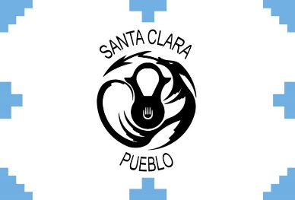
The Federal Emergency Management Agency (FEMA)

Emergency Management Institute (EMI)
and the
Pueblo Santa Clara
invite you to attend the
FEMA Tribal Train the Trainer (L8585)
April 22 – 26, 2024 from 8:00 am - 5:00 pm
at the Santa Claran Hotel Casino, 464 N. Riverside Dr., Espanola, NM 87532

Course Purpose: To train and enable Tribal members and Tribal personnel to deliver the FEMA core curriculum to their own Tribal members in their own Tribal communities.
This 5-day course provides tribal emergency management/response personnel, tribal government employees, and tribal leaders with an in-depth and comprehensive training in instructional methods and delivery techniques in three of the Tribal courses of the FEMA Tribal curriculum
Intended Audience: Tribal emergency managers/emergency response personnel, Tribal government agency/department heads, Tribal government employees, Tribal leaders.

The training and materials are free.
Travel expenses are the responsibility of the student’s organization.

NOTICE: You’ll need a FEMA Student Identification Number (SID) for your application. You can obtain a SID by going to https://cdp.dhs.gov/femasid/ Please register online if possible, but can still register onsite in class.
Online registration is open: Online Registration: DHS-FEMA General Admissions Application, Course number is L8585 Start Date April 22, 2024.
If any questions, please contact
James Baca, 505-901-3069, jfbaca@santaclarapueblo.org or
Mary Reevis at 202-765-7806, mary.reevis@FEMA.DHS.gov
Ensure you are accepted to the course prior to making travel arrangements.

TRAINING FACILITY
Santa Claran Hotel Casino, 464 N. Riverside Dr., Espanola, NM 87532

HOTEL INFORMATION
Santa Claran Hotel Casino, 464 N. Riverside Dr., Espanola, NM 87532
https://www.santaclaran.com/ Contact Matt Romero for Room Rate: (505) 901-2588

AIRPORT INFORMATION
Albuquerque International Sunport Airport, ABQ, 2200 Sunport Blvd SE, Albuquerque, NM 87106
88 miles from the training in Espanola, approximately 1.5 hours

