The Federal Emergency Management Agency (FEMA)
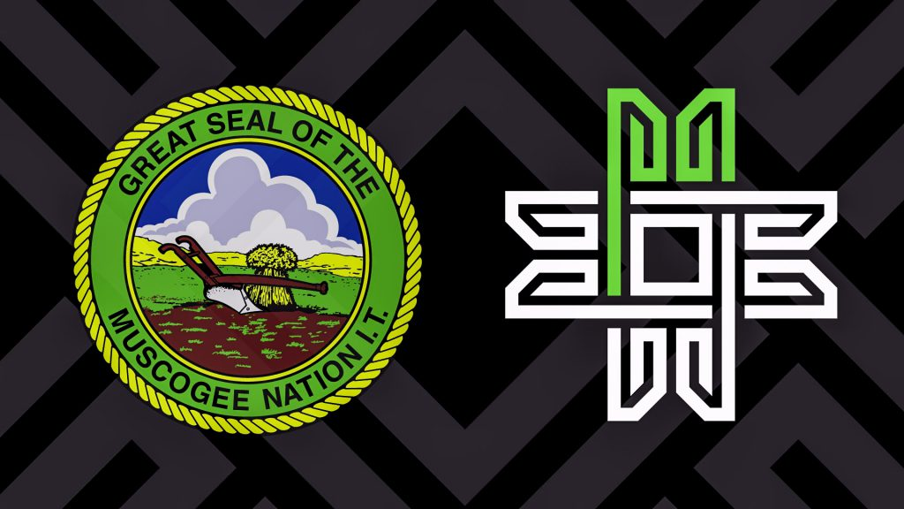
Emergency Management Institute (EMI)
and the
Muscogee Creek Nation
invite you to attend
Tribal Train the Trainer (L8585)
Jul 29 – Aug 2, 2024 from 8:00 am - 5:00 pm
at River Spirit Casino Resort, 8330 Riverside Pkwy, Tulsa, OK 74137

Course Purpose: To train and enable Tribal members and Tribal personnel to deliver the FEMA core curriculum to their own Tribal members in their own Tribal communities.
This 5-day course provides tribal emergency management/response personnel, tribal government employees, and tribal leaders with an in-depth and comprehensive training in instructional methods and delivery techniques in three of the Tribal courses of the FEMA Tribal curriculum
Intended Audience: Tribal emergency managers/emergency response personnel, Tribal government agency/department heads, Tribal government employees, Tribal leaders.

The training and materials are free.
Travel expenses are the responsibility of the student’s organization.

NOTICE: You’ll need a FEMA Student Identification Number (SID) for your application. You can obtain a SID by going to https://cdp.dhs.gov/femasid/ Please register online if possible, but can still register onsite in class.
Online registration is open: Online Registration: DHS-FEMA General Admissions Application, Course number is L8585 Start Date July 29, 2024.
If any questions, please contact
Bobby Howard, 918-732-7891, bhoward@muscogeenation.com
Or Mary Reevis at 202-765-7806, mary.reevis@FEMA.DHS.gov
Ensure you are accepted to the course prior to making travel arrangements.

TRAINING FACILITY
River Spirit Casino Resort, 8330 Riverside PKWY, Tulsa, OK 74137

HOTEL INFORMATION
River Spirit Casino Resort, 8330 Riverside PKWY, Tulsa, OK 74137, 888-748-3731
River Spirit Casino Tulsa | River Spirit Casino Resort (riverspirittulsa.com)

AIRPORT INFORMATION
Tulsa International Airport, TUL, 7777 E. Apache St., Tulsa, OK 74115
22 miles from the training in Tulsa, approximately 30 minutes

