

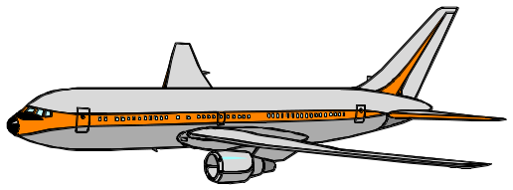

FEMA Travel Rules and Regulations
Instructor Guide

DF 502



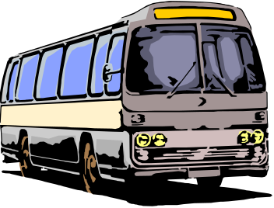

Disaster Field Training Operations
August 2004

COURSE GOAL

To prepare FEMA employees to be prudent travelers and abide by the agency travel regulations.

COURSE OBJECTIVES

By the end of this workshop, students will be able to:

- Explain the Prudent Traveler Rule.
- Arrange for travel as prescribed by the regulations.
- Differentiate between local and out-of-area travel.
- Describe lodging expense limits.
- Explain the meals and incidental expense allowance.
- Discuss travel bonus programs and government travel.
- Use the government travel card in compliance with the rules.
- Determine which expenses are reimbursable.
- Identify what receipts are required for reimbursement.

TARGET AUDIENCE

This training is appropriate for all FEMA personnel that may be required to travel in the performance of their jobs.

APPROXIMATE TIME

1 hour

CONTENTS

This course includes the following:

- Overview
- Purpose of travel reimbursement
- Prudent Traveler Rule
- Travel reservation process
- Per Diem Rates
- Travel bonus programs
- Government travel card
- Eligible expenses
- Summary

PREPARING
Use the following checklist to help you prepare for this course:
Supplies and Equipment

- Visuals 1 through 28
- PowerPoint projector or overhead with screen
- Chart paper, easels, and markers

Handout Materials

- Student Manual

NUMBER OF INSTRUCTORS

One instructor is sufficient to teach this course.
INSTRUCTOR QUALIFICATIONS

Instructors should have training experience, as well as knowledge of the travel policies and regulations. If you are inexperienced, request an experienced instructor to co-instruct the first session with you.

COURSE OVERVIEW
Visual 1   | 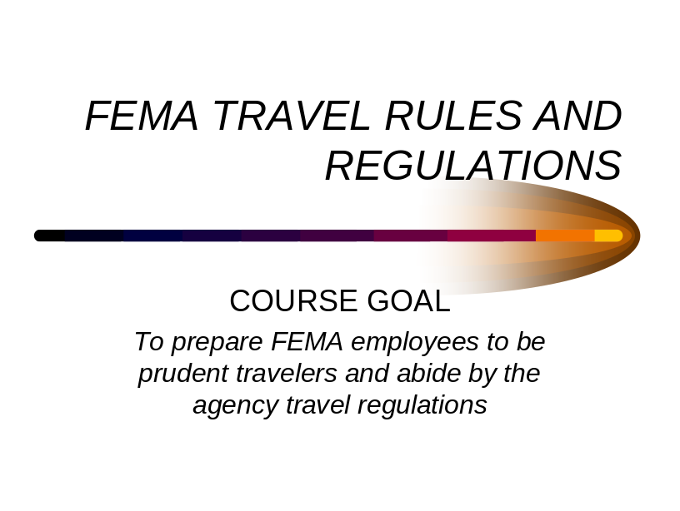
  FEMA Travel Rules and Regulations Student Manual | Distribute the student manual titled “FEMA Travel Rules and Regulations” so they may take notes during the training.  Begin this course by reviewing the following goal and objectives:  COURSE GOAL  To prepare FEMA employees to be prudent travelers and abide by the agency travel regulations.

COURSE OVERVIEW
Visuals 2 & 3 | 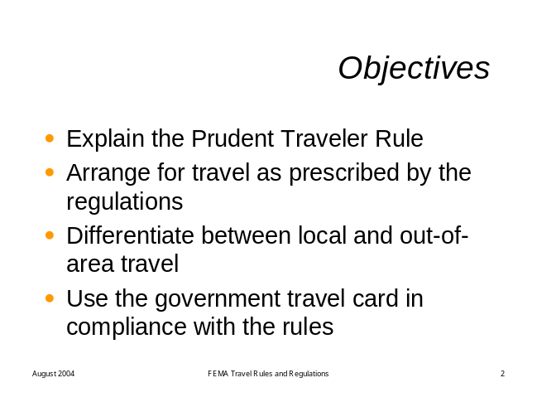  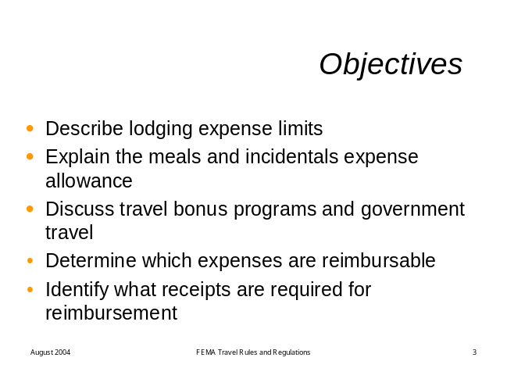

COURSE OBJECTIVES

By the end of this workshop, students will be able to:

- Explain the Prudent Traveler Rule
- Arrange for travel as prescribed by the regulations.
- Differentiate between local and out-of-area travel.
- Describe lodging expense limits.
- Explain the meals and incidental expense allowance.
- Determine which expenses are reimbursable.
- Identify what receipts are required for reimbursement.

REGULATIONS OVERVIEW
Visuals 4 and 5 | 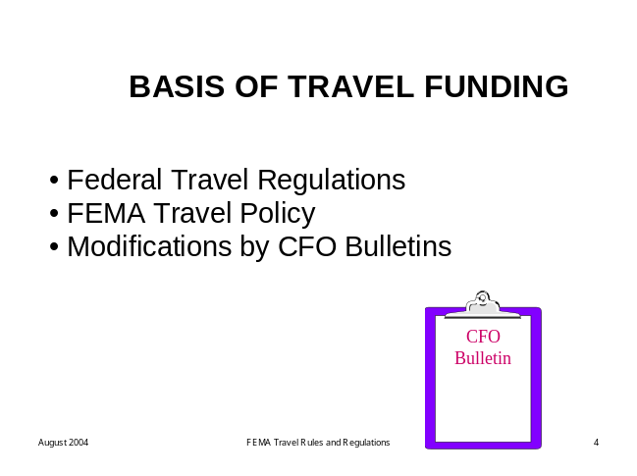  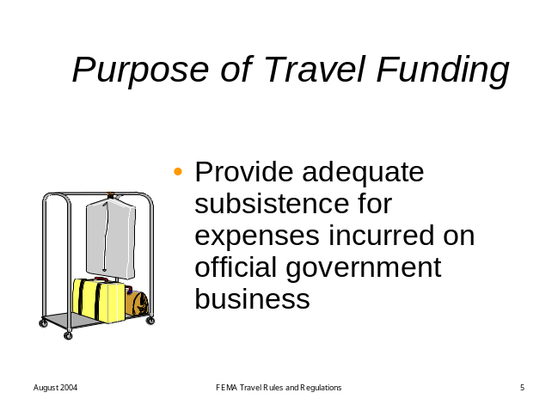
  Visual 6 | Review the following key points about travel:  - The basis for travel funding is provided by the following:  - Federal travel regulations (governed by GSA).  - FEMA travel policy.  - Modifications by Chief Financial Officer (CFO) Bulletins  - (Update/clarify/modify FEMA policies, not the regs).  - Travel reimbursement exists to provide adequate funding for employees to cover the expenses they acquire on official government travel.  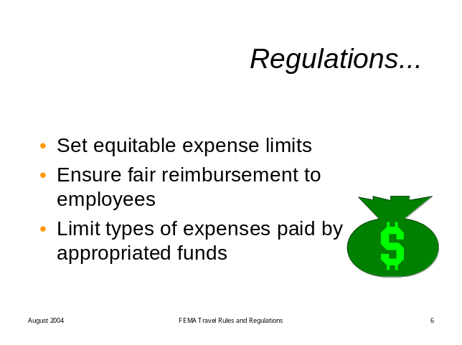  - The regulations govern that reimbursement by:  - Setting equitable limits on expenses.  - Ensuring fairness to all employees on reimbursement.  - Limiting types of expenses paid by appropriated funds.  - The regulations are not intended to be punitive in nature. However, there are serious consequences for failure to comply.

PRUDENT TRAVELER RULE
Visual 7 | Display the following visual.  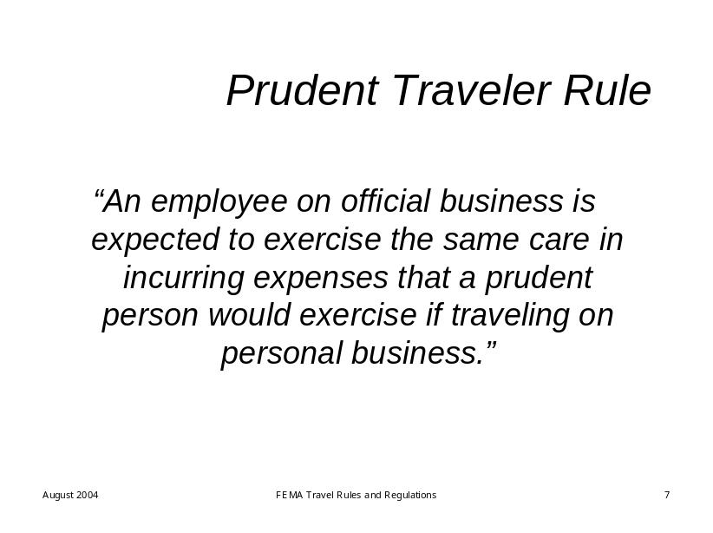
 | Review the following key points about the Prudent Traveler Rule:  “An employee on official business is expected to exercise the same care in incurring expenses that a prudent person would exercise if traveling on personal business.”
 | Discussion Question:  What does this mean in real life terms?
Possible responses:
- Find reasonably priced hotels…
- …rental cars
- …restaurants
- …transportation fares
- NO LUXURY ACCOMODATIONS!

TRAVEL RESERVATION PROCESS
Visuals 8 and 9 | Display the following visuals.  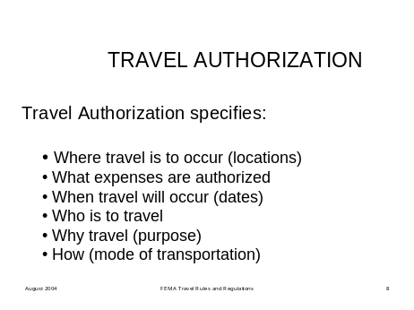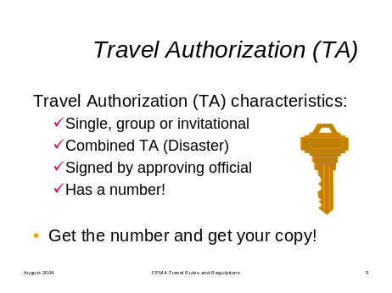
Review the following key points about TAs:

Your Travel Authorization (TA) is the key to your whole travel process. It is important for everything from making reservations to filing your reimbursement claim. It must be attached to voucher for reimbursement

- TA provides the WHO, WHAT, WHERE, WHEN, WHY (purpose), and HOW

  - Travel Authorization (TA) characteristics
  - Single, group or invitational
  - Combined TA for disaster (CTA)
  - Signed by approving official
  - Has a number!

- Get your TA number first, to proceed with the reservation process. You can book flight reservations while you are waiting for your TA number, but you must have a TA number to purchase your ticket.

NOTE: DON’T LEAVE HOME OR TRAVEL WITHOUT IT!

TRAVEL RESERVATION PROCESS
Visual 10 | Display the following visual:  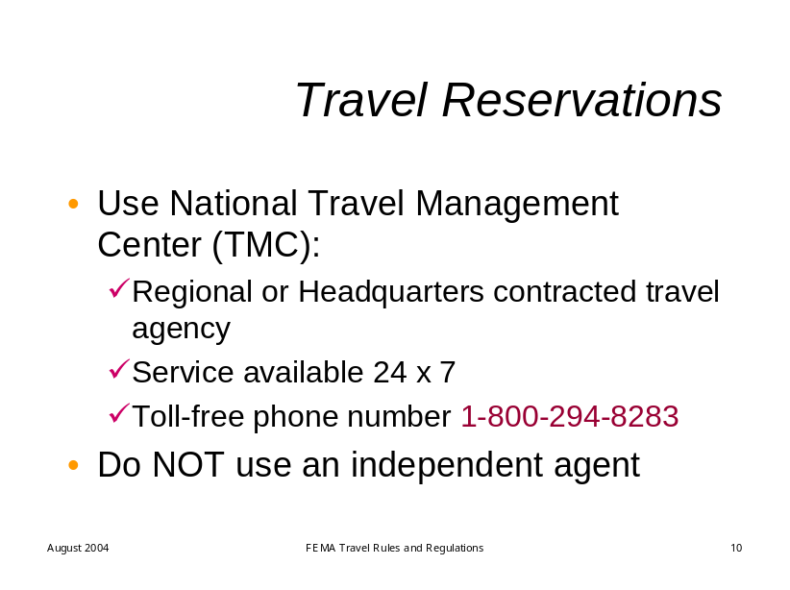
Review the following key points about National Travel:

- Use the National Travel Management Center (TMC) designated by FEMA
- Regional or Headquarters contracted travel agency.
- Service available 24 hours daily 7 days per week.
- Toll-free phone number 1-800-294-8283.

- Do NOT use an independent travel agent.

TRAVEL RESERVATION PROCESS
Visual 11 | Display the following visual.  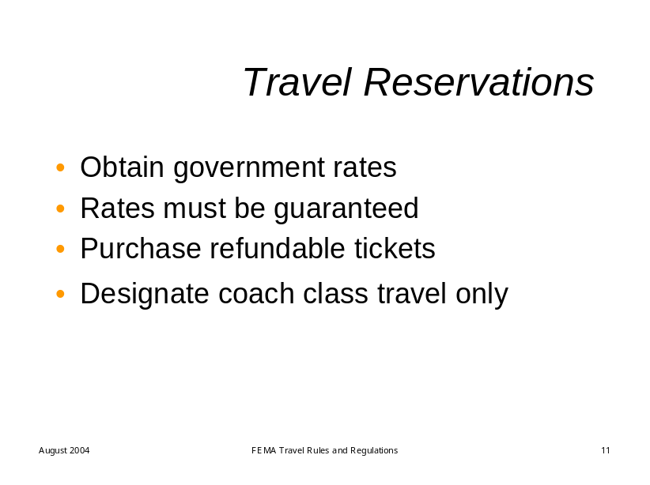

Review the following key points about air travel:

When you call the TMC to get your airline tickets:
- Obtain government rates.
- The rates should be guaranteed.

Purchase refundable tickets.
- Designate coach class travel only.
- Use your government credit card to purchase the tickets.

Do not fly First Class under any circumstances!

When you use the TMC, most of these issues will be addressed because they also know the contract and the rules. If they make changes, such as using a different carrier, they can justify them within the contract they have with FEMA.

PRIVATELY OWNED VEHICLE
Visual 12 | Display the following visual.  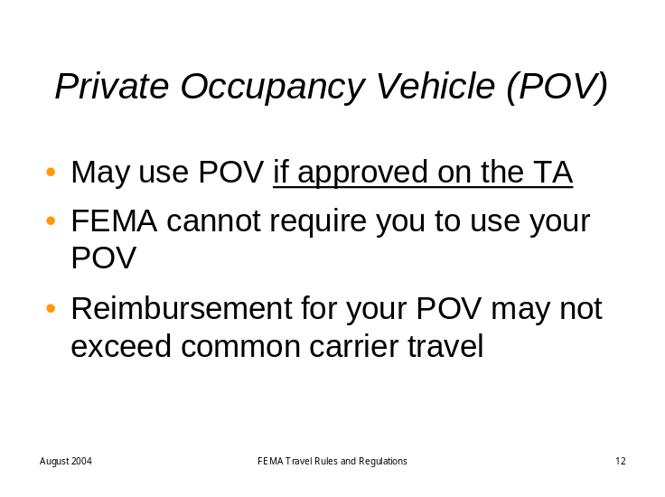

Review the following key points about private vehicles:

You may use your own vehicle if approved on the TA.

The reimbursement rates, as of August 2004, are:

37.5 cents per mile for privately owned vehicles.
- 28.5 cents per mile for motorcycles.
- 99.5 cents per mile for privately owned airplanes.

The government cannot require you to use your POV.
  - Reimbursement for the use of your POV may not exceed that of common carrier travel.

Discussion Question:

When would want to use your POV?
- If less travel time by your POV than by air.

For example:
The DFO is 250 miles from your home, with an estimated 4 ½ hours travel time.

The closest airport to you is 100 miles away, and the airport closest to the DFO is 50 miles from it. Getting to the airport, plus wait time there, plus flight time, plus time from the airport city to DFO by rental car equals 6 hours.

PER DIEM RATES
Visual 13 | Display the following visual.  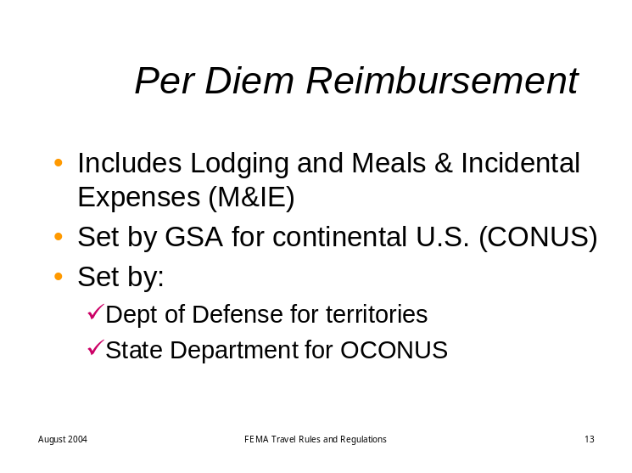
Review the following key points about per diem:

The term Per Diem means the daily rate of reimbursement for lodging, meals and incidental expenses.

The rate is set by the General Services Administration for the continental United States (excludes taxes in CONUS)

New rates effective each October for the new fiscal year can be found online at http://www.gsa.gov/perdiem.

The rate is set by the Department of Defense for outside the continental US in the territories (HI, AK, GU, USVI, etc. taxes are included)

Travel outside the U.S. is set by the Department of State.

LODGING
 | Display the following visuals.
Visuals 14 and 15 | 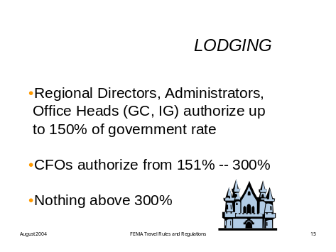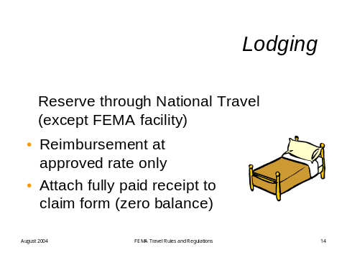
Review the following key points about lodging:

For your lodging

- You must reserve your lodging through National Travel. However, some situations occur where you will reserve accommodations through someone at the DFO because they have a block of rooms.

- You will receive reimbursement at the approved rate only, so know what that rate is, however you make your reservations.

- You must attach your original fully paid receipt (showing zero balance) to your travel claim form for reimbursement.

- Lodging per diem rates can be adjusted by the RDs, Administrators, Office Heads, or the CFO. However, nothing can be adjusted greater than 300%.

MEALS AND INCIDENTAL EXPENSES
Visual 16 | Display the following visual.  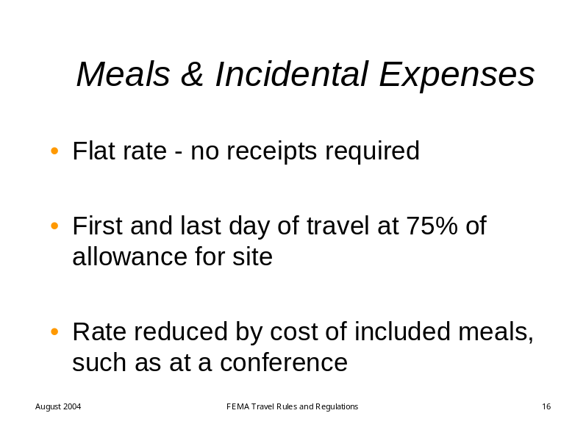
Review the following key points about M&IE:

- Flat rate, based on location - no receipts required

- First and last day of travel at 75% of allowance for site

- Rate reduced by cost of included meals, such as at a conference

MEALS AND INCIDENTAL EXPENSES
Visual 17 | Display the following visual.  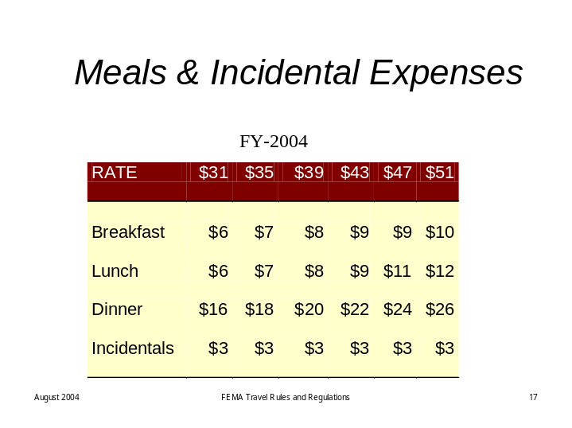
Review the following key points about M&IE:

This chart (SM pg. 6) shows the distribution of costs by meal for the various M&IE rates. The rate is determined by ZIP code location of the DFO in compliance with the GSA regulations.

If you choose to spend more than these allocations, you will not be reimbursed.

And there are special per diem rates for the Emergency Management Institute and Noble Training Center. Your housing is provided and the meals are available at low cost.

TRAVEL BONUS PROGRAMS
Visual 18 | Display the following visual.  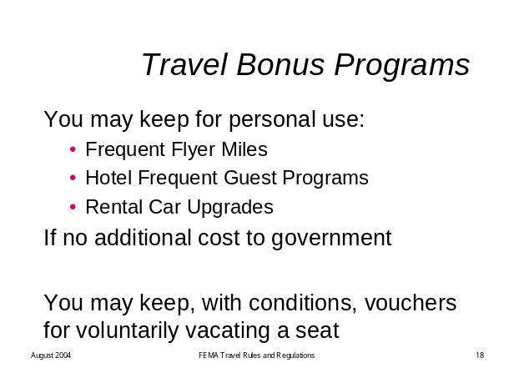
Review the following key points about travel bonus programs:

- Frequent Flyer Miles
- Hotel Frequent Guest Programs
- Rental Car Upgrades

May be kept for personal travel if acquired while on government travel and if there is no additional cost to the government. (Effective January 24, 2002 - CFO Bulletin #109).

If you acquire these types of benefits, you must:

- Set up your own account.
- Pay any fees for that account.
- Notify National Travel of the account numbers.

You may use the airline points for personal travel or for service class upgrade while on government travel.

- Voluntarily Vacating a Seat:

You may keep the travel coupon for yourself if:
- You personally assume additional costs accrued by vacating the seat.
- You take annual leave for the delay during official duty hours.
- Your official duties are not hampered by the delay.

GOVERNMENT TRAVEL CARD
Visuals 19 and 20 | Display the following visuals.  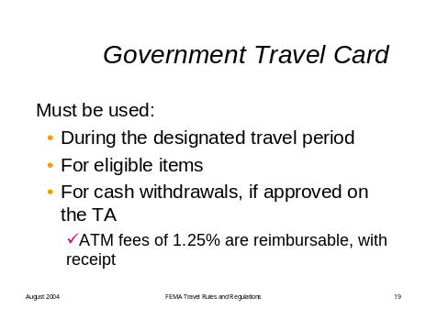  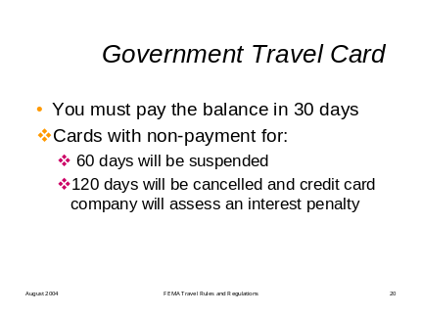
Review the following key points about the government travel card:

- The government travel card issued in your name may be used:

- During the designated period of travel.
- For items eligible for reimbursement.
- For cash withdrawals, if approved on the TA:
- Two days before travel.
- Up to $350 per week to use for Meals & Incidental Expenses.
- ATM fees of 1.25% are reimbursable, with receipt (using government travel card only).

- You MUST pay the statement within its payment period of 30 days.

- Cards with non-payment for 60 days will be suspended.
- Cards with non-payment for 120 days will be cancelled and the credit card company will assess an interest penalty which cardholders must pay at their own expense.

ELIGIBLE EXPENSES
Visual 21 | Display the following visual.  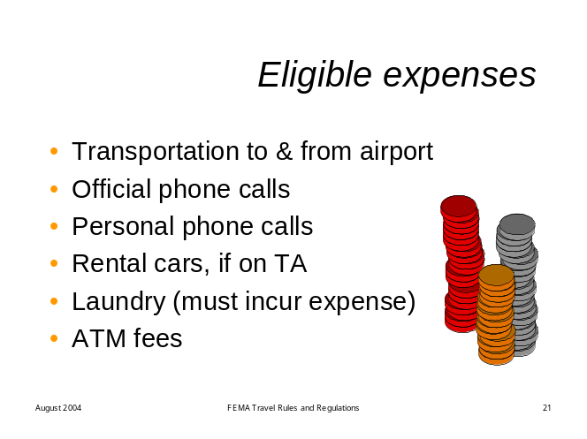
Review the following key points about reimbursable expenses:

Certain other expense may be eligible for reimbursement. These include:

- Transportation to and from the airport at home or the DFO.
- You will be reimbursed for the actual amount with a receipt, as long as it does not exceed round trip cab fare.
- Official phone calls made at your own expense.
- You must note to whom the call was made on the receipt you attach to your claim form.
- Personal phone calls to a maximum of $15 per week and not to exceed $5 per day.
- There is no receipt required for these calls.
- Rental cars:
- Must be authorized on the TA
- Using a Military Traffic Management Command (MTMC) contracted company (done through National Travel), when possible.
- If not using a MTMC company, acquire government rates.
- Insurance add-ons NOT reimbursable.
- Laundry (MUST INCUR EXPENSE)
- Actual expenses up to $15 per week (5 to 7 days). Claim only expenses actually incurred.
- Cost of making cash withdrawal using your government credit card.
  - You must attach the receipt to your travel voucher to receive reimbursement for the actual cost.

INELIGIBLE EXPENSES
Visual 22 | Display the following visual.  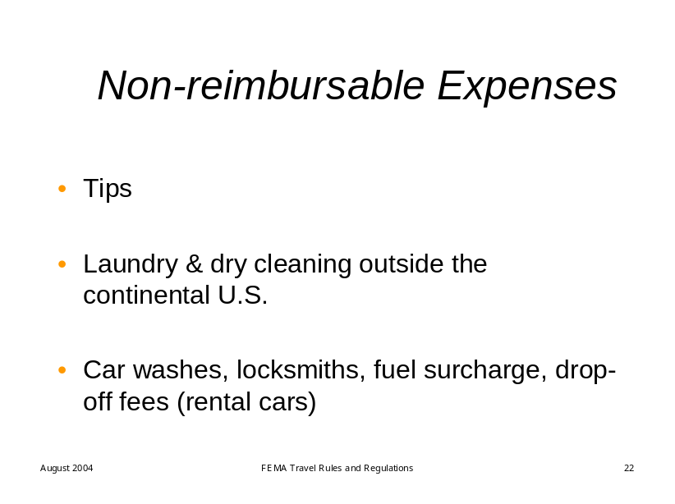
Review the following key points about non-reimbursable expenses:
You will NOT be reimbursed for other items. These include

- Tips to wait staff, porters, bell staff and so on.

- Laundry and Dry Cleaning outside the continental US.

- Car washes. fuel surcharges, etc.

If you incur these expenses, you pay them yourself.

LOCAL TRAVEL
Visual 23 | Display the following visual.  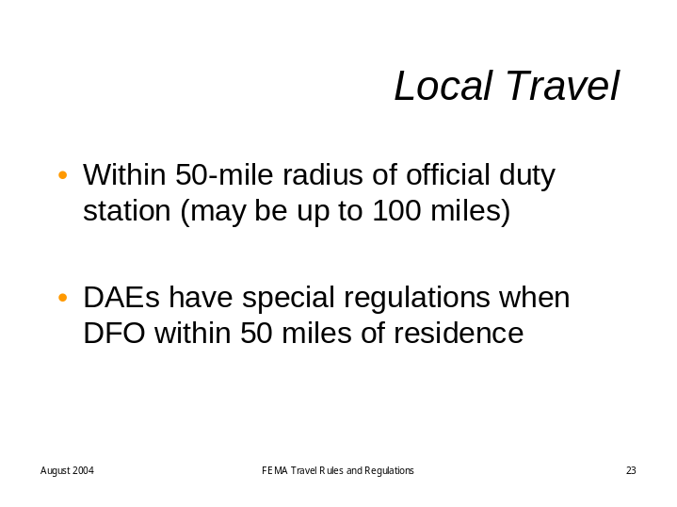
Review the following key points about local travel:
- Local travel is defined as within 50 miles of your official duty station. In some circumstances, the circle may be 100 miles.

- DAEs living within 50 miles of the DFO have special regulations that apply.

RECEIPTS
Visuals 24 and 25 | Display the following visual.  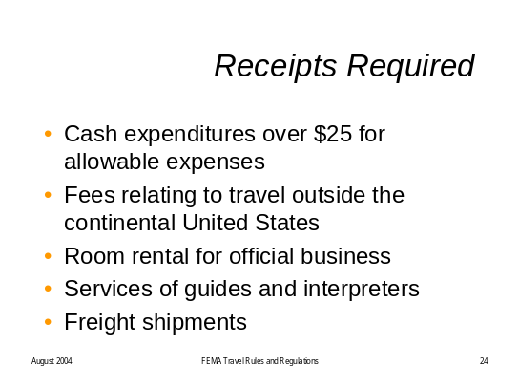  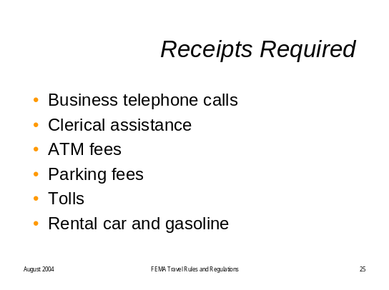
Review the following key points about receipts:
- Receipts are required for
- Cash expenditures in excess of $25 for allowable expenses.
- Fees relating to travel outside the continental United States.
- Rental of rooms for official business (i.e., meeting rooms up to 14 days – although you should check with logistics).
- Services of guides and interpreters.
- Shipments of freight.
- Business telephone calls (provide who, when, etc.).
- Clerical assistance.
- ATM fees.
- Parking fees.
- Tolls.
- Rental car, fully paid receipt.
- Gasoline for rental car.

TRAVEL CLAIM FORMS
Visual 26 | 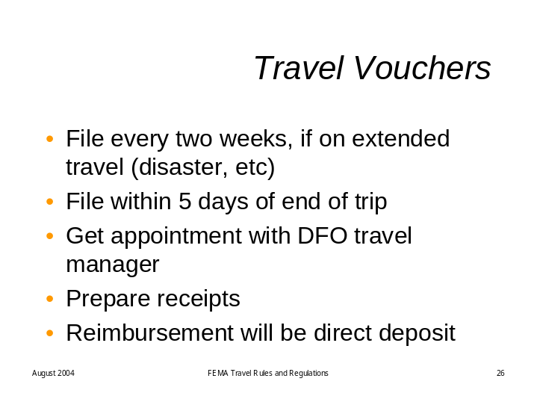

Review the following key points about Travel Vouchers:

- If you are on extended travel, every two weeks

- Make an appointment to see the DFO Travel Manager.
- Prepare your receipts (tape to 8 ½ x 11 sheet of paper).
- File a claim with the DFO Travel Manager who prepares your voucher using Travel Manager software
- All reimbursement by Direct Deposit.
- Separate Direct Deposit authorizations for travel and payroll.

Split Pay
Visual 27 | . 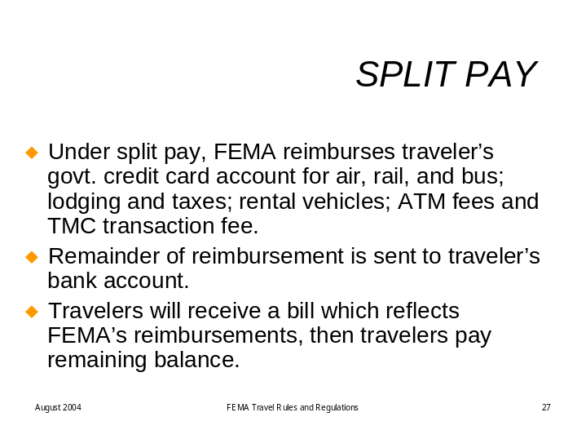
Review the following key points about Split Pay:
Under split pay, reimbursements for Common Carrier (air, rail, bus), lodging, lodging taxes, rental vehicles, ATM fees, and the TMC transaction fee will be sent directly to the traveler’s credit card account.

The remainder of the reimbursement will be sent to the traveler’s bank account by electronic funds transfer. Travelers will continue to receive a Government Credit Card bill which will reflect the reimbursements made by the agency to the traveler’s account. Travelers are still responsible for payment of the remaining balance on the bill.

You must make your travel purchases using your government credit card. Purchases made with personal credit cards while on government travel may not be eligible for reimbursement.

SUMMARY
Ask students to read through the list of Travel Dos and Don’ts on the last page of their Student Manual to see if they have any questions.

The list is repeated below for your convenience.
Travel Tips | Do have a TA completed before your travel begins.  Do keep receipts for all expenses over $25 and all gasoline and ATMs.  Do make your transportation reservations through National Travel.  Do use e-tickets where possible.  Do stay at commercial lodging meeting the hotel/motel fire safety act.  Do obtain approved travel advances for official travel on your government credit card.  Do take taxi or have someone drive you to the airport. You may claim full taxi cost or the round trip cost of a ride provided it is less than a taxi.  Do refuel your rental car prior to returning the car.  Do cancel all transportation and lodging reservations before travel date if plans change.  Do use your government issued credit card for all official travel expenses.  Do file travel vouchers every two weeks on extended travel or within 5 days of the end of your trip.  Do keep a copy of the voucher and receipts for your records.  -----------------------------------------------------------------------------------------  Don’t pick up transportation tickets at the airport counter, use e-tickets.  Don’t accept rental car insurance. (The Federal Government has agreements with car rental companies for insurance and will not reimburse the cost of additional insurance.)  Don’t obtain cash with your government credit card more than 2 days prior to official travel or when you are not on approved travel.  Don’t purchase a round trip airline ticket if you are on extended travel.  Don’t travel by first class on an airline.  Don’t use restricted nonrefundable or penalty fare tickets.  Don’t accept refueling services offered by the rental car companies.  Don’t allow your government credit card bill to become overdue.  Don’t pre-pay your rental car or lodging bill.  Don’t incur dual lodging costs without prior authorization from the CFO.  Don’t incur expenses in excess of GSA authorized per diem without prior approval.  Don’t claim lodging and M&IE if you live within 50 miles of your official duty station or DFO.

Visual 28 | Display the following visual.  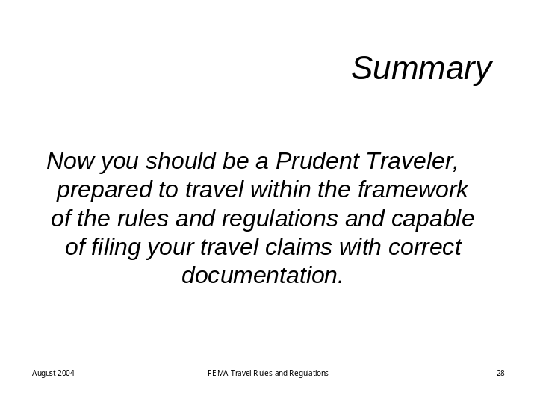
Review the following key points:
- Now you should be a Prudent Traveler, prepared to travel within the framework of the rules and regulations and capable of filing your travel claims with correct documentation.

